|  |
| --- |
| **Dell VRTX rack conversion (The JDN way)** |

Introduction 1

Required tools 1

Disclaimer 1

Conversion 2

# Introduction

The rack conversion procedure proposed by Dell is overly complicated and time consuming. As a work around, we propose the following procedure instead.

# Required tools

The required tools to complete this task are

* #1 Phillips screwdriver
* Torx wrench provided with the Rack conversion kit

# Disclaimer

The location of the JDN number is not correct in the following pictures! Please use the VRTX assembly manual to find out where to place JDN number.

# Conversion

1. Remove the VRTX top cover

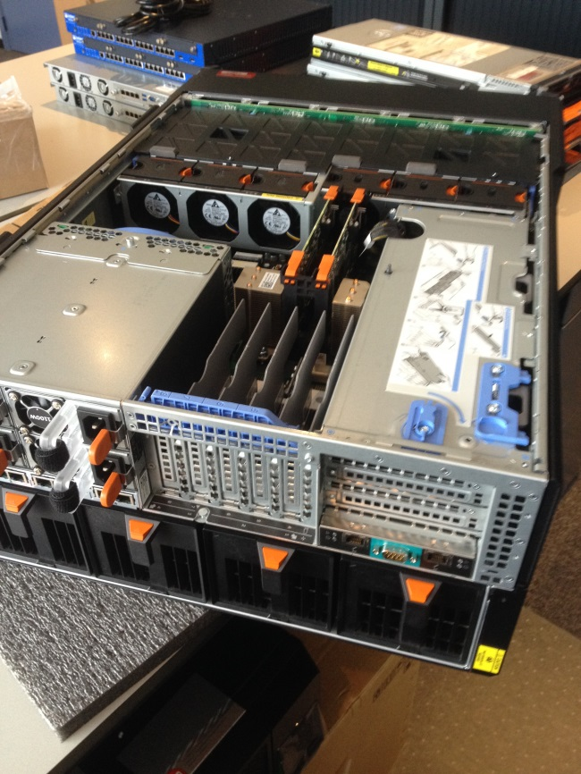

1. Remove the black screw at the rear left side of the VRTX (next to the blower under the CMC)

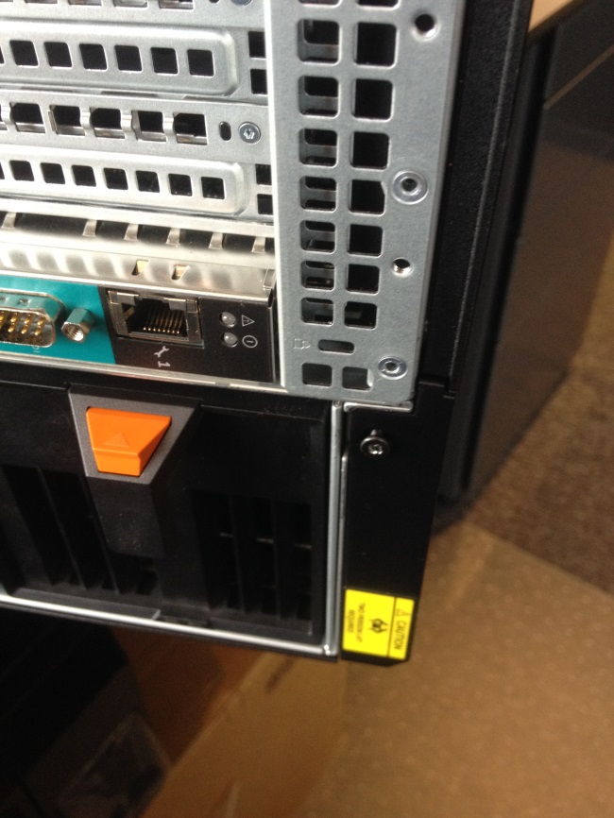

1. Pull back the blue clip and flip out the left side PCI door

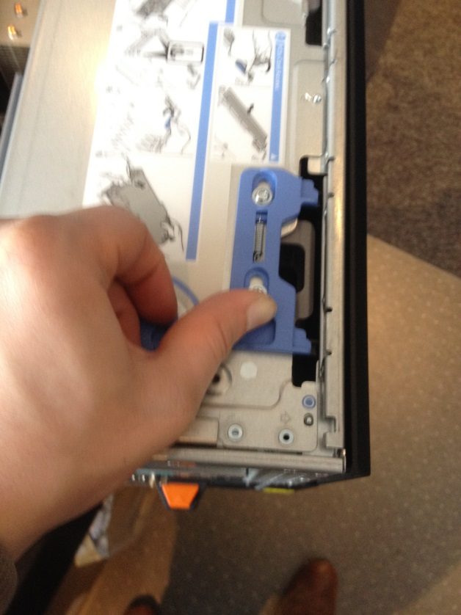 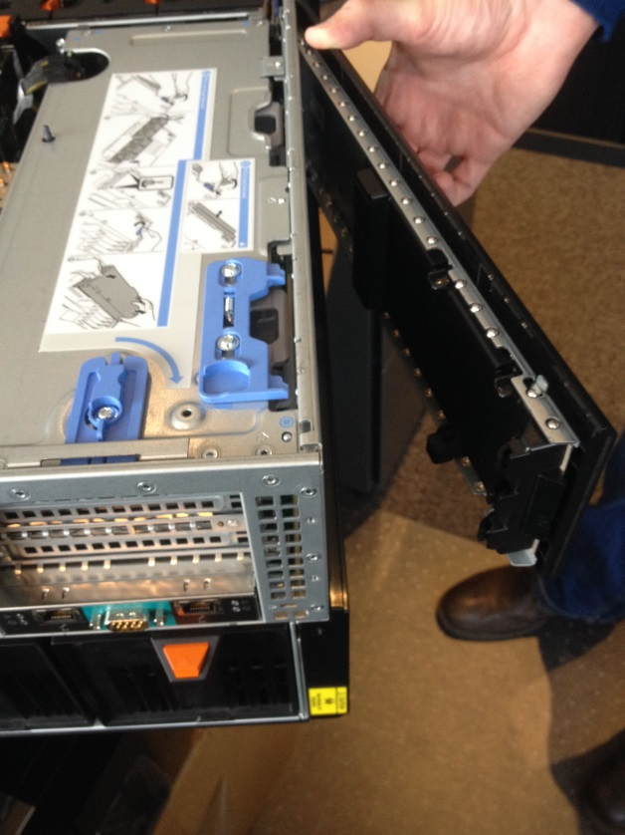

1. Remove the left side lower panel by sliding it to the rear of the VRTX

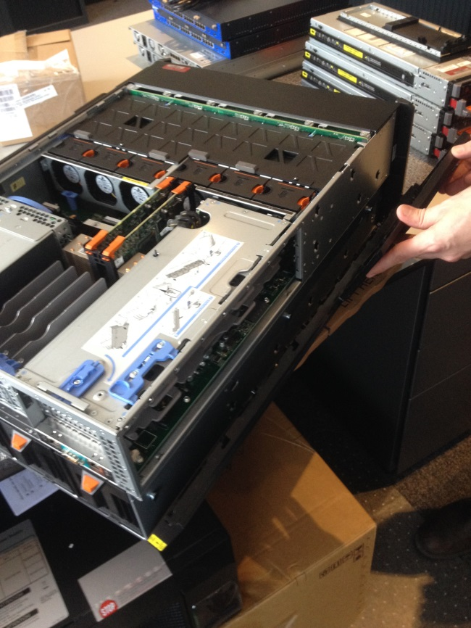

1. Take the left side PCI door (removed in step 3) and remove the plastic finish of the metal frame by unscrewing the screws

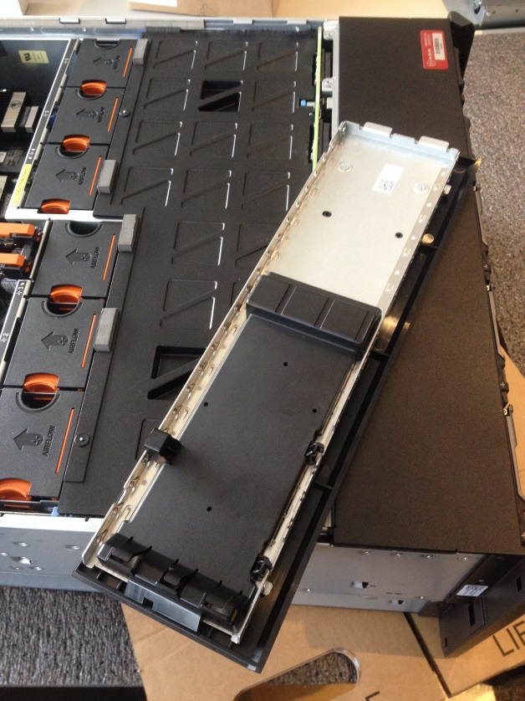 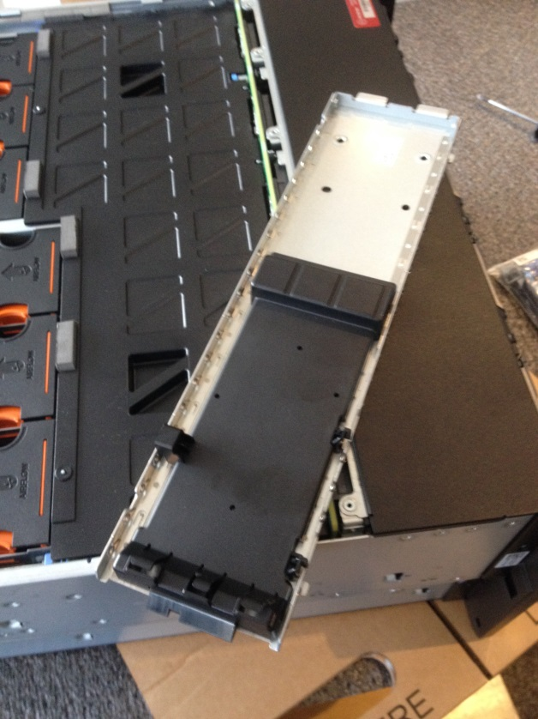

Before After

1. Fill the PCI door gab in the VRTX frame by mounting the blocking plate which was created in the previous step. The blocking plate should click when mounted properly

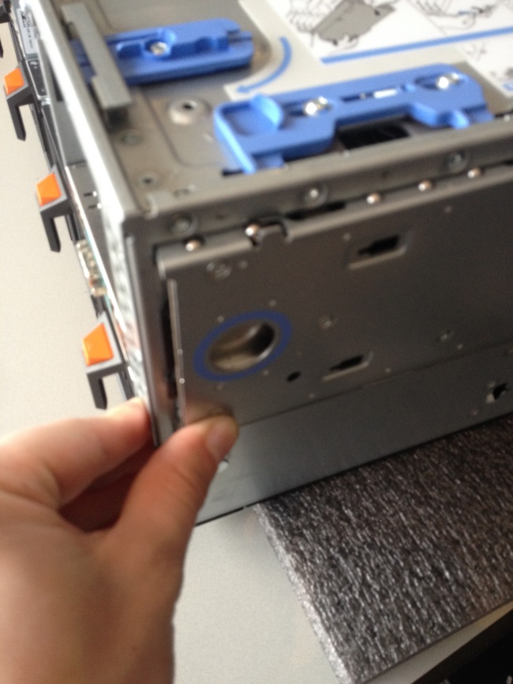

1. Remove the right side rear screw which is holding the right side VRTX cover

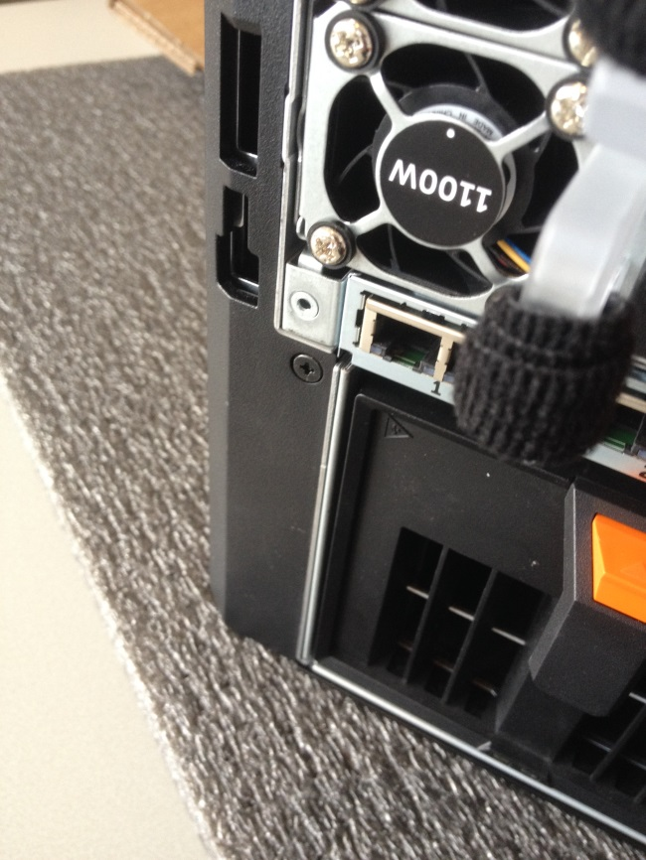

1. Remove the right side finish as shown in the picture below

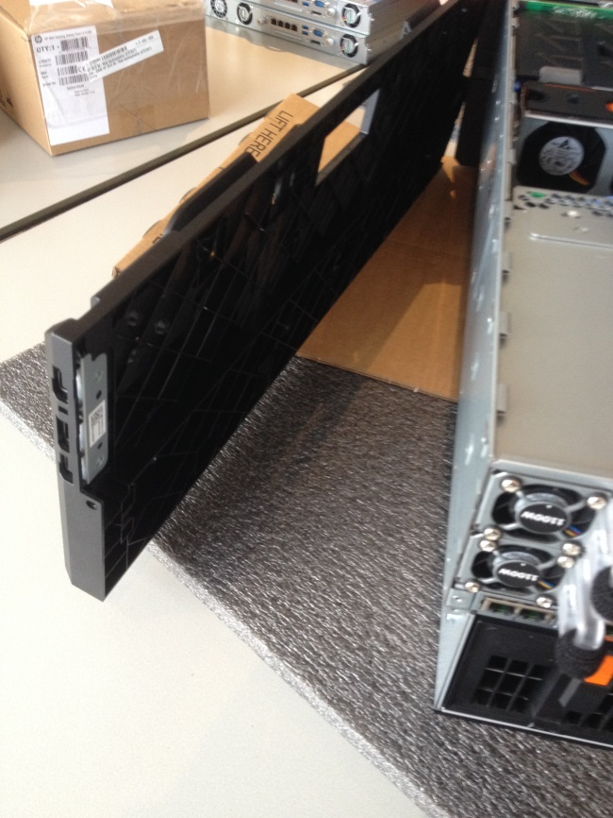

1. Remove the screws which are holding the left rack ear at the front in place

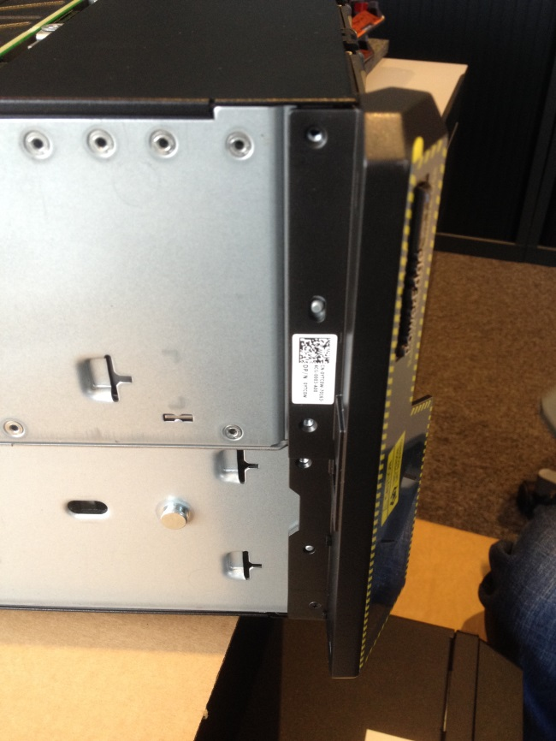

1. Carefully remove the rack ear and take out the 2 torx screws which are holding the blocking plate in place. Be gentle, the cable to the display cannot be disconnected!

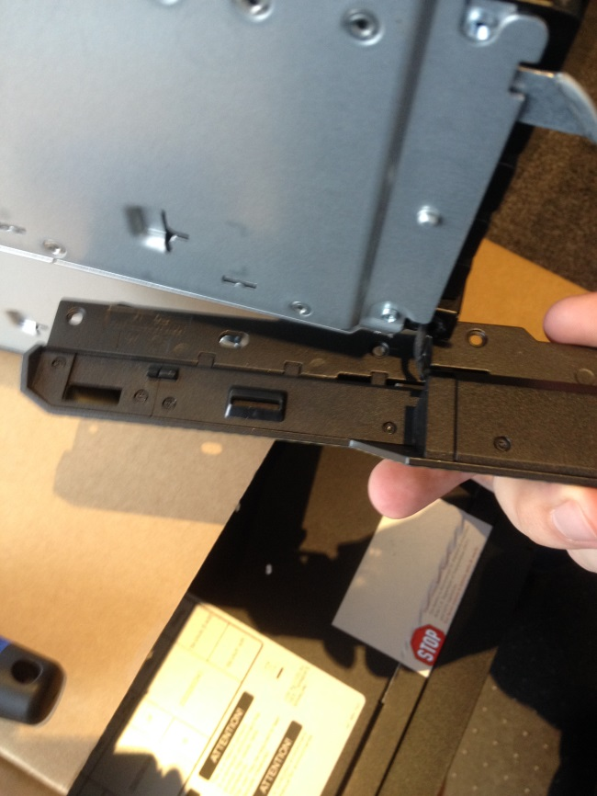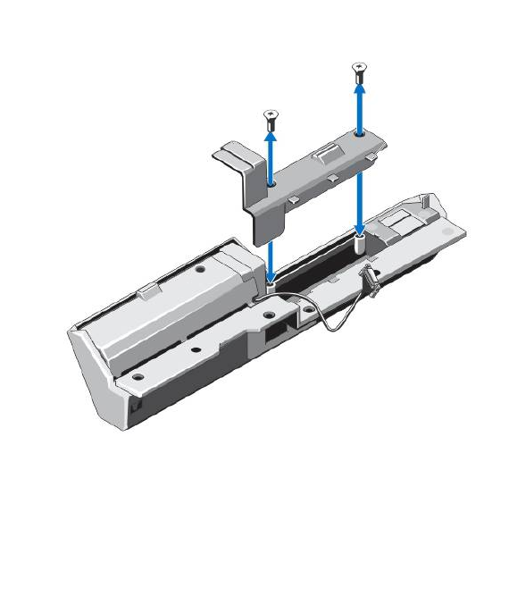

1. Insert the correct piece of the VRTX rack mount kit in the gab of the removed blocking plate

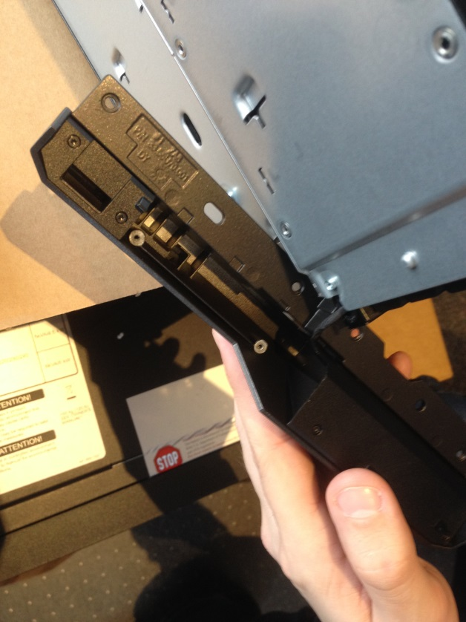 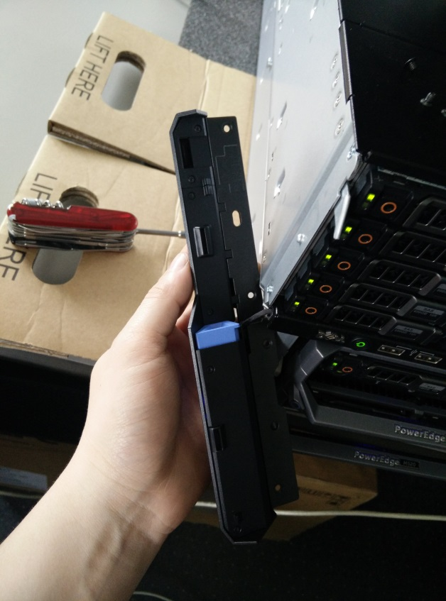

1. Mount the rack ear back to the chassis
2. Repeat steps 9 to 12 for the right side rack ear

When all steps are followed as described in this manual, the VRTX should be ready for rack mounting.